
Home to School/College Transport
IMPORTANT NOTICE APPLICATION DEADLINES
If you believe a child/young person is entitled to Home to School/College Travel Assistance for the new school year (September 2026-July 2027) and you wish to submit an application, please be aware that the application window for new travel assistance, renewals and SEND travel reviews is now OPEN and forms must be submitted no later than:
Friday 29 May 2026
Any applications received after this date cannot be guaranteed to have travel in place for the start of the 2026/27 academic year.
Transport is only provided at the normal start and finish times of the school in which your child/young person is attending.

’If you or someone you know needs help to understand or read this document, please contact us’’: education.transport@rotherham.gov.uk

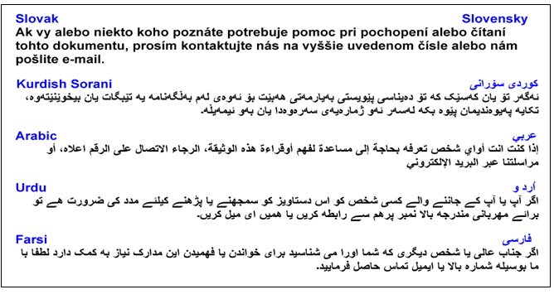

Contact Details
For further enquiries, please contact the Home to School Transport & Travel Service at:
education.transport@rotherham.gov.uk
Eligibility and Application progress enquiries

R&E-Passengertransport@rotherham.gov.uk
Home to school transport operational enquiries





All application forms, and further information on all home to school/college transport (including Zoom Zero Travel Passes) can be found on the Travel section of Rotherham SEND Local Offer page: https://www.rotherhamsendlocaloffer.org.uk/transport-getting-around/ or by scanning the QR Code:


Please note this guidance relates to the upcoming school Academic year September 2026 - July 2027 only.

NEW APPLICATIONS
SEND & Zoom Zero Travel Passes

Applications should be submitted as soon as a school or college place is confirmed.
To assess entitlement for a travel solution the Local Authority needs to receive:
• A completed application form
• Confirmation of school/college base (where more than one base exists or times vary from main school site)
• Confirmed timetable
• Supporting information (Copies of EHCPs can be accessed by us, however where a child/young person does not have an EHCP additional supporting medical evidence will be required with the application. In addition proof of low income where required)
• Updated contact details for parents/carers and emergency contacts

RENEWAL APPLICATIONS
Zoom Zero Travel Passes

A renewal application is required every year to renew every pass for each child/young person, even if nothing has changed.
REVIEW APPLICATIONS
SEND Travel Assistance (Travel Solutions)

New applications must be submitted where any of the following apply, at any point in time:

- The child/young person is moving home
- The child/young person is moving to a different educational setting
- parent/carer wishes the Local Authority to consider an alternative travel solution
- The young person is currently in Year 11 and moving into post-16 education (including where they are staying at the same school)*
- The young person is in Year 12 or above and is returning to college* as they require their eligibility and current travel solution to be re-assessed.

*All transport applications for home to college assistance will be required to be accompanied by a confirmed timetable.

Transport will not be reinstated without a new application being received and entitlement re-confirmed.
Suitable travel solutions will be considered on an individual basis and include:
- Zoom Zero Travel Pass (free bus pass)
- Independent Travel Training
- Parental Reimbursement
- Space on a shared route with an external/internal transport operator

TEMPORARY SYSTEM DOWNTIME – PLEASE BE AWARE
Rotherham Council will be moving to a new Education Data System.
Systems will be unavailable between 9th –20th July 2026.

During this time:
• No applications can be submitted
• No renewals or reviews processed
• No changes recorded
• Transport will operate manually
• Safeguarding procedures remain active

Future Changes to the Application Process

Once the new Education System is implemented, the application process for the following areas may change:
- SEND Travel Assistance
- Zero Fare (Zoom Zero) Passes
- Post-16 travel assistance
- Post-19 travel assistance
- Renewal and reassessment processes

Further guidance & information will be issued to all families and education providers ahead of these changes.

